Login to GoToWebinar and Click on the name of your Webinar
Click the Start button to get the webinar screen up
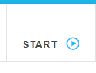
To start the Broadcast - Click Start to begin the webinar (it will record it the broadcast for you)
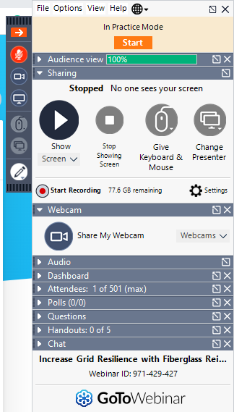

The Microphone button will be Orange and on Mute – Click the button to Unmute yourself (the button will turn Green) Remind your Panelists – to mute themselves when they are not talking
To show your face while you present – Click the Camera button and Click Share Webcam (so audience can see you) It will turn green if you are sharing
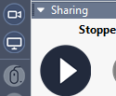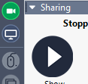
To Share Your Screen – Have your presentation up and close all other windows before you start the webinar – Click Show Screen for the audience to see your presentation (similar to teams). The button will turn green while you are sharing your screen
Watch attendee box – Monitor the box and wait a few minutes at the start for people to join
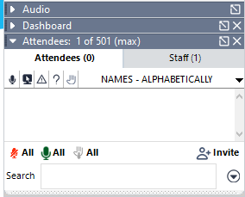
During your introduction - Tell Audience to use the Question Box to ask questions which will be answered after the presentation (Have Terry monitor the questions)

Once the presentation and questions are over…
To end the broadcast - click File – exit – end webinar – pop up will say for everyone - Click Yes
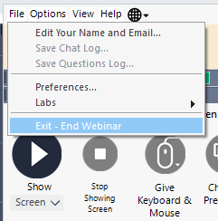
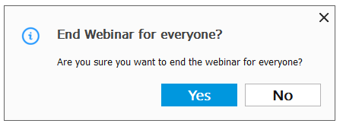
At the end of the Webinar, when you finish the session – it will ask to convert the recording - click YES
You will see the GoToWebinar Screen and the file being processed - the recording will take time to process.

