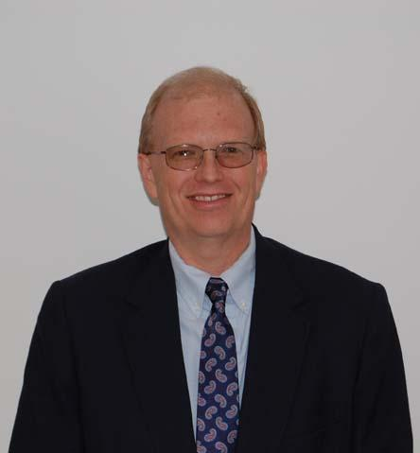

Ronald W. Allison - Director of Engineering, Creative Pultrusions, Inc.
Ron received a B.S. in Mechanical Engineering Technology at the University of Pittsburgh in 1999, graduating summa cum laude. Currently, he serves as Director of Engineering at Creative Pultrusions, Inc. (CPI) in Alum Bank, PA and serves as the Director of Environmental and Safety for Creative Composites Group. Ron began his career at Creative Pultrusions in 1986 as a tool & die maker. Ron has held several positions at Creative Pultrusions during his 35 years of service including Machine Shop Supervisor, Research and Development Engineer, R & D Engineering Manager and Senior Design Engineer before taking over duties as the Director of Engineering in 2000. Ron is also current on the OSHA 40 hr HAZWOPER, OSHA HAZWOPER supervisor training, 30 hr OSHA General Industry Safety and Health and the EPA method 9 Visible Emissions. Ron loves outdoor activities especially fly fishing and spending time with his grandchildren.

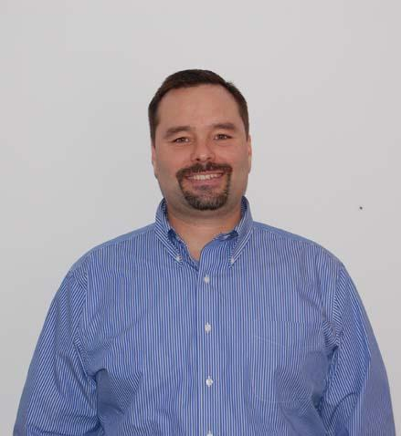

Dustin Troutman - Director of Marketing and Product Development, Creative Pultrusions, Inc.
Dustin Troutman received his B.S. in Civil Engineering Technology from the University of Pittsburgh at Johnstown in 1993. Currently, he serves as Director of Marketing and Product Development at Creative Pultrusions, Inc. (CPI) in Alum Bank, PA. During his 25 years with CPI, Mr. Troutman has been instrumental in the market investigation and development of major pultrusion products and product lines associated with civil/structural applications – SUPERPILE™ pipe piles, SuperLoc™ sheet piles, and FRP transmission and distribution poles and cross arms, to name a few. He continues to be a key player in the development of codes and standards in support of the FRP pultrusion industry. Mr. Troutman is also a co-inventor, holding four patents related to pultruded systems. Additionally, Mr. Troutman oversees sales, marketing and product development for the majority of the Creative Composites Group of companies. Mr. Troutman is a member of professional associations, including ASCE, ANSI and ASTM. He is a past president of the Pultrusion Industry Council and is currently the vice chair of the Utility and Communication Structures Committee. He is a member of the Project Advisory Committee (PAC), charged with developing the ASCE/LRFD standard for pultruded structural profiles.

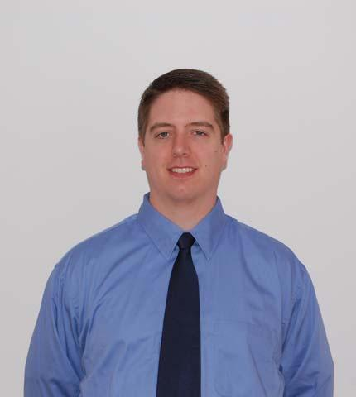

Jeremy Mostoller - Product Design Engineering Manager, Creative Pultrusions, Inc.
Jeremy Mostoller received his B.S. in Engineering Science with a minor in Engineering Mechanics from the Pennsylvania State University in 2001. Currently, he serves as Product Design Engineering Manager at Creative Pultrusions, Inc. (CPI) in Alum Bank, PA. Mr. Mostoller has spent the entirety of his professional career working in the field of composite materials. During his tenure at CPI, which began in 2006, Mr. Mostoller’s primary role has been engineering sales support and new product design and analysis, including the use of finite element modeling. He has aided in the development of major pultrusion products and product lines associated with civil/structural applications including SUPERPILE™ pipe piles and FRP transmission poles and cross arms. Mr. Mostoller has been crucial in developing test methods and custom test frames for use in the prototyping phase and life cycle management of such products. Mr. Mostoller is a member of ASCE and ASTM, in which he has aided with the development of standards for designing and testing structures utilizing pultruded FRP materials.

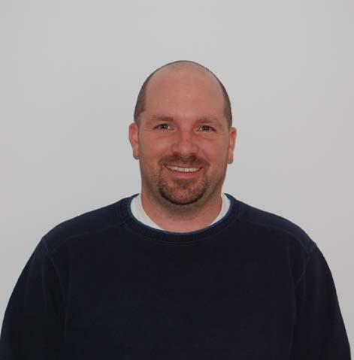

John D. Plunkard – Equipment and Estimating Engineer, Creative Pultrusions, Inc.
John received a B.S. in Mechanical Engineering Technology from The University of Pittsburgh in 1999 graduating with cum laude honors. John also passed the Engineer-in Training (EIT) in 1998. John began his career at Creative Pultrusions in 1997 as a summer intern. He continued to work part time until graduating from college in 1999. He just celebrated his 25 years of service on May 5, 2022. Over the years, John has held several positions and worked for various departments within Creative Pultrusions. He started as a Research and Development engineer. He then took a position in the Machine Group where he was responsible for new equipment design and OEM machine building. This position later evolved into a supervisory role with being responsible for all of the pultrusion machines on site. In 2004 when the company reorganized roles, John was given the position of Equipment and Facilities Engineer. His responsibilities included everything from the previous position as well as managing the entire facility. This also included directing the Maintenance Department and supervising Manufacturing Engineering. As other individuals retired, John absorbed other responsibilities such as estimating and contract review. In his current role as Equipment and Estimating Engineer, John is still responsible for the facilities management of the entire Manufacturing Complex in Alum Bank. He is in charge of all new equipment design and procurement. He oversees Manufacturing Engineering and coordinates large fabrication projects and work cell layouts and design. He also assists in large project estimating. Currently, John reports directly to the Director of Engineering and has 5 direct report engineers and 8 maintenance personnel that he is responsible for. John is also a member of ASME and NFPA.

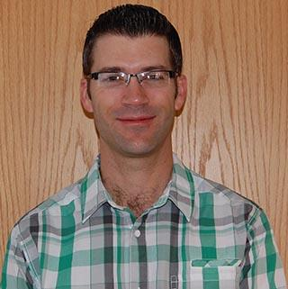

Chad Kauffman – Manufacturing Engineer, Creative Pultrusions, Inc.
Chad received his B.S. in Mechanical Engineering from Penn State University in 1994. He began his career at Creative Pultrusions in 1995 as an R&D Engineer and has served as a Manufacturing Engineer since 1999. His primary role is the implementation and technical support of value-added fabrication processes to CPI’s pultruded profiles. Mr. Kauffman is heavily involved in the design and purchase of fabrication equipment and fixturing and the setup of assembly processes and work cells using LEAN Manufacturing principles. Chad works extensively with adhesives, coatings, urethane foam, and dispensing equipment and oversees the qualification of new materials. He develops Work Instructions, assists with Fabrication routings for new and existing products, and also provides troubleshooting support for the Fabrication department. Other significant roles include sales support, estimating, and packaging design and planning.

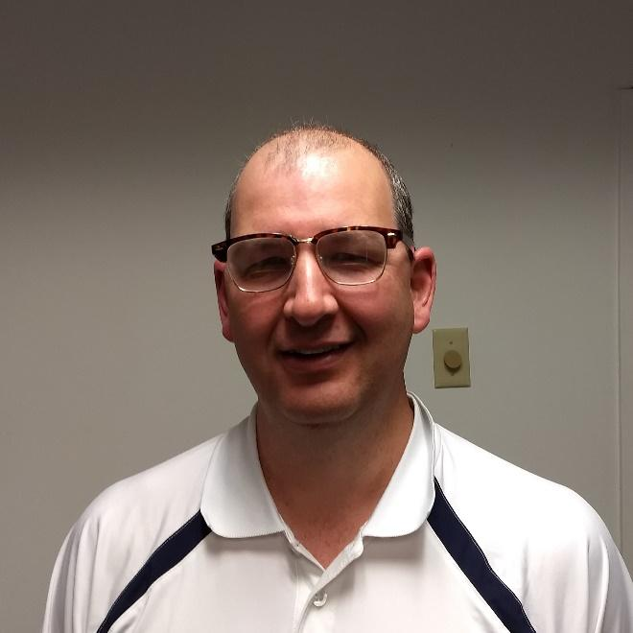

Daniel E. Winey, P.E. - Chief Structural Engineer, Creative Pultrusions, Inc.
Dan Winey, P.E. received his B.S. in Civil Engineering from the Pennsylvania State University at University Park in 1992. Currently, he serves as the Chief Structural Engineer at Creative Pultrusions, Inc. in Alum Bank, PA for the ET Techtonics bridge product line since 2019. Mr. Winey is licensed as a Professional Engineer in the states of Pennsylvania and West Virginia. Mr. Winey has 19 years of structural engineering experience with design, permitting and plan preparation of bridge and building projects. His experience with AASHTO bridge codes and the International Building Code is essential to the design and permitting of the ET Techtonics bridge product line. He has extensive experience with projects related to truck live loading. Mr. Winey overseas design/fabrication plans and specifications for bridge and boardwalks. Mr. Winey has endeavored recently to design and coordinate testing of the longest FRP truss bridge in the world.

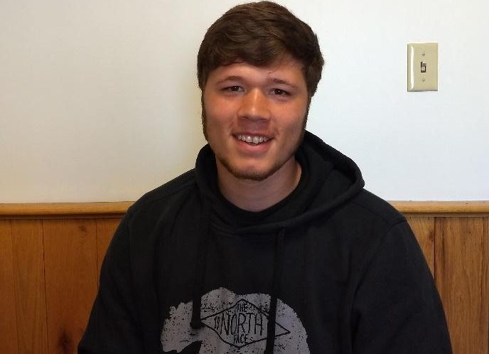

Trent Crouse - Product Design Engineer, Creative Pultrusions, Inc.
Trent Crouse received his B.S. in Civil Engineering from the University of Pittsburgh at Johnstown in 2019. Currently, he serves as Product Design Engineer at Creative Pultrusions, Inc. (CPI) in Alum Bank, PA. While earning his Civil degree he became certified for Field Testing Technician through the American Concrete Institute (ACI). For his senior project he helped his team design a recreational facility. His major roles were conducting a soil analysis, concrete footing and structural design, and processing survey data into Civil 3D software. During his first two year’s he has assisted the sales team with drawings, produced new designs, and helped analyze ET Techtonic’s bridge designs. He took part in research and development for the SUPERPILETM pipe pile splice as well as test specific FRP sections for strength analysis. Two major projects he is contributing to is the development of a new design guide conforming to LRFD codes and specifications as well as the advancement of a new deck that is compliant for AASHTO H-5 loading.

Tyler Wiley – Quality Assurance Engineer/Document Control Manager, Creative Pultrusions, Inc.
Tyler Received a B.S. In Electro-Mechanical Engineering Technology from Penn State University at Altoona in 2019. Currently, he serves as Quality Assurance Engineer/Document Control Manager, Creative Pultrusions, Inc. (CPI) in Alum Bank PA. Mr. Wiley has spent the entirety of his 3 years since graduating college at Creative Pultrusions. In those three years Tyler has moved through multiple positions involving him in all Engineering aspects of CPI. Tyler Has recently moved to his current position in Quality which involves creating and controlling the Quality Specification/ Inspection sheets, performing inspections and maintain the Scrap database. His role as Document Control Manager requires him to annually review and update all documents inside of Creative Pultrusions. The second part of that role is ensuring Creative Pultrusions continues to follow the ISO9001:2015 Standard with respect to documentation Control, and training procedures.

Cole Feathers – Chemical Engineer, Creative Pultrusions, Inc.
Cole Feathers received his B.S. in chemical engineering with a minor in mathematics from the University of Pittsburgh at Johnstown in April 2022. He is currently starting his professional career with Creative Pultrusions head quartered in Alum Bank, Pa. Cole is an avid outdoors man and can be found outside when not at work. He also spends a lot of his time at his family’s camp in Potter County, Pa.

Corbin Corrente- Technical Engineer, Creative Pultrusions, Inc.
Corbin Corrente received his B.S. in Mechanical Engineering from the Pennsylvania State University in 2014. Corbin is a new hire for CPI in March 2022. Currently, he serves as a Technical Engineer at Creative Pultrusions, Inc. (CPI) in Alum Bank, PA. His primary duties include performing all aspects of quality assurance, supporting manufacturing and engineering, CNC programing, and maintaining the CNC equipment for fabrication. Prior to working with CPI, Corbin worked as a Mechanical Engineer for 8 years in manufacturing of unmanned air systems. His experiences include composite part & mold design, mechanical design and development, configuration management, development of technical data packages, CNC programming, and conforming manufacturing to the AS9100 quality standard.

Kelsy Valko – Chemical Engineer, Creative Pultrusions, Inc.
Kelsy Valko received her B.S. in Chemical Engineering from the University of Pittsburgh at Johnstown in 2022. Kelsy recently began her career as a Chemical Engineer with Creative Pultrusions, Inc. in Alum Bank, PA. She has previous experience working as a Quality Engineering Intern at a welding and fabrication company.

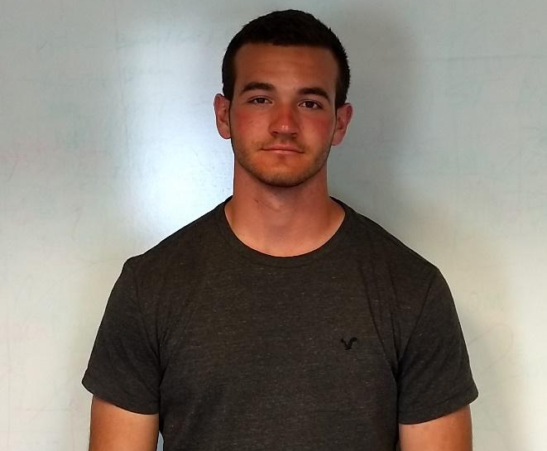

Cody Lohr – Manufacturing Project Engineer, Creative Pultrusions Inc.
Cody Lohr received his B.S. in Electro-Mechanical Engineering Technology from the Pennsylvania State University in 2022. He currently works as a Manufacturing Project Engineer at Creative Pultrusions, Inc. (CPI) in Alum Bank, PA. Cody has worked part time at Creative Pultrusions Inc, as an engineering intern for the past two summers. In the spring of 2022, he worked on his senior design project team. Their goal was to produce a hands-free electric skateboard from scratch. His major roles were using SolidWorks to draw the design, fabricating the design, and using his abilities for C++ coding to program the Arduino Mega chip controlling the board. Cody is a recent hire at CPI and will assist with drawings, troubleshooting machines, and many more tasks.

Amir H. Houshmandyar, PhD, EI, A.M. ASCE - Composites Engineer, Creative Pultrusions, Inc.
Amir is a Civil/Structural Engineer and earned his doctorate at West Virginia University (WVU), Morgantown, West Virginia, in 2022. Currently, he is serving as Composites Engineer at Creative Pultrusions, Inc. (CPI) in Alum Bank, PA.
Prior to joining CPI, Amir held Graduate Research/Teaching Assistant positions in WVU and University of Tehran, Iran. His most recent works include experimental evaluation of multi-bolted FRP joints, rehabilitation of civil infrastructures, and durability of thermoplastic and thermoset FRP composites under harsh environments.
Amir is an associate member of Structural Engineering Institute (SEI), American Society of Civil Engineers (ASCE), and Society for the Advancement of Material and Process Engineering (SAMPE). His fields of expertise are predominantly in the design of vehicular bridges and seismic design of residential buildings.

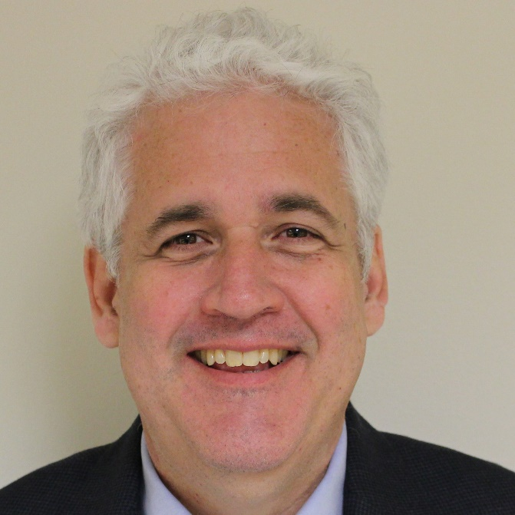

Alexander Thibodeau – Director of Operations, CCG Molding Division
Alex began his career with Kenway in 2008. He has a B.S. in Mechanical Engineering Technology from the University of Maine and has an A.A.S in Mechanical Drafting from New Hampshire Technical College. Alex started his career in Pulp & Paper as a draftsman in 1989. After starting as a draftsman, he progressed to a maintenance engineer followed by General Superintendent of Maintenance. Alex next spent several years in the sawmilling industry holding several positions including Operations Manager for the largest EWP sawmill in the US. Positions held since at Kenway include Project Engineer, Production Director, Director of Business Development and currently Director of Operations. While at Kenway, much of his time has been focused on new market and product development. In his current role he is responsible for supporting the Augusta Maine operations and successful integration with the Dayton Ohio group as the Creative Composites Group – Molding Division.

Adam Rose - Engineering Manager, CCG Molding Division
I am currently the engineering manager for the Dayton branch of CCG molding division. I have been working in the Composite Advantage group since July of 2012. I graduated from the University of Dayton with a bachelors in civil engineering and received my PE in 2021 and am currently licensed in the state of Ohio. Prior to working with CA, I worked in residential and commercial construction in project management for approximately 5 years. With Composite Advantage I have been involved with all aspects of part fabrication, including developing the floor operation sheets for molding & finishing the parts, project shop drawing generation and panel design. I consider myself an expert in vacuum infused sandwich panels and laminates. Outside of work I enjoy staying active by playing sports, scuba diving, riding atv’s and traveling with my wife and son.

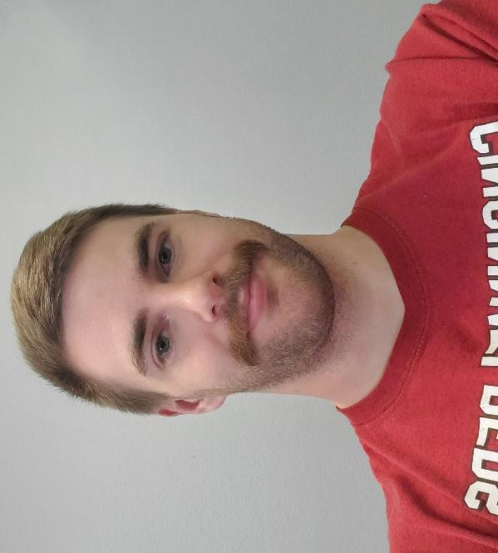

Clayton Costello - Design Engineer, CCG Molding Division
My name is Clayton Costello, and I am a design engineer at Composite advantage. I started at Composite advantage in December 2020. Before that I worked at Henny Penny as a product development engineer for 3 years working and leading development on a commercial gas fryer and automated fryer system. I graduate from Miami university with a bachelor’s degree in Electro-mechanical Engineering Technology. My engineering expertise is in product development and testing from experience in R&D and quality control work. Outside of work I enjoy riding dirt bikes, mountain bikes, snowboarding, Jiu jitsu, and weightlifting.

Archie Scott III – Product & Project Manager, CCG Molding Division
Archie has a Bachelor of Science in Mechanical Engineering and a Minor in Mathematics. Archie began his career with the Creative Composites Group Composite Advantage as a design engineer intern, developing drawings and calculations for pedestrian bridges. After graduating from Ohio University in 2019 with his B.S in Mechanical Engineering, Archie joined the group full time as Project Manager. He brought with him the discipline and skills learned while leading teams of engineers through multiple years of engineering design competitions. Such as the Air Force Research Lab’s Turbine Optimization Challenge and Space Port America’s colligate rocket competition. He currently serves as the Product & Project Manager for Composite Advantage. In this role, Archie helps bring new composite products to market by collaborating with customers to optimize the design for manufacturing and performance.

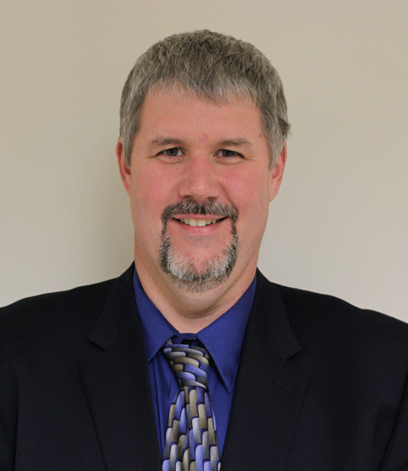

Paul Dumoulin - Senior Project Engineer, CCG Molding Division
Paul began at Kenway in 1994. He is currently in charge of estimating, design, and project management. Paul holds a Bachelor of Science in Mechanical Engineering Technology from the University of Maine. Paul specializes in corrosion resistant design supporting Kenway’s heavy industrial customers. With over twenty-five years of experience, he can help our clients solve problems unique to their industry. His certifications include Certified Composite Technician (CCT), First Aid/CPR, and OSHA 10hr.

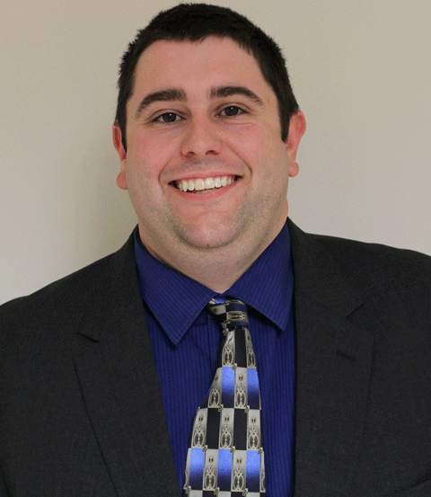

Jordan Couture - Project Engineer, CCG Molding Division
Jordan received his B.S. in Mechanical Engineering from the University of Maine in 2015. While in college he worked summers in the Pump & Paper Industry which he then entered after graduation. While in the Pulp & Paper Industry he concentrated in the operation of power generating equipment, steam systems, and electrical distribution. Jordan started at Kenway in 2017 and oversees the structural fabrication department along with assisting in the corrosion resistant design/fabrication, the design/fabrication of infused structures, and field install/repair services. His certifications include First Aid/CPR, OSHA 30hr in General Industry.

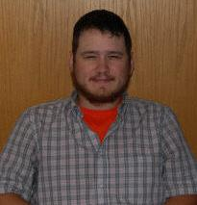

Bretton Nedwreski – Project Engineer, Tower Tech
I graduated from Penn State Behrend with a Bachelors degree in Mechanical Engineering Technology in 2015. I was hired at Creative Pultrusions shortly after as a Project and Manufacturing Engineer. From 2015 to 2022 I worked on various projects from building pultrusion and fabrication equipment to in depth customer projects. In 2018 I assisted with moving Tower Tech from the Oklahoma City plant to Alum Bank. In 2022 I transitioned fully over to Tower Tech to work on new product development, improvement to existing products, and performance evaluations. Outside of work I enjoy spending time with my family and various outdoor activities.

